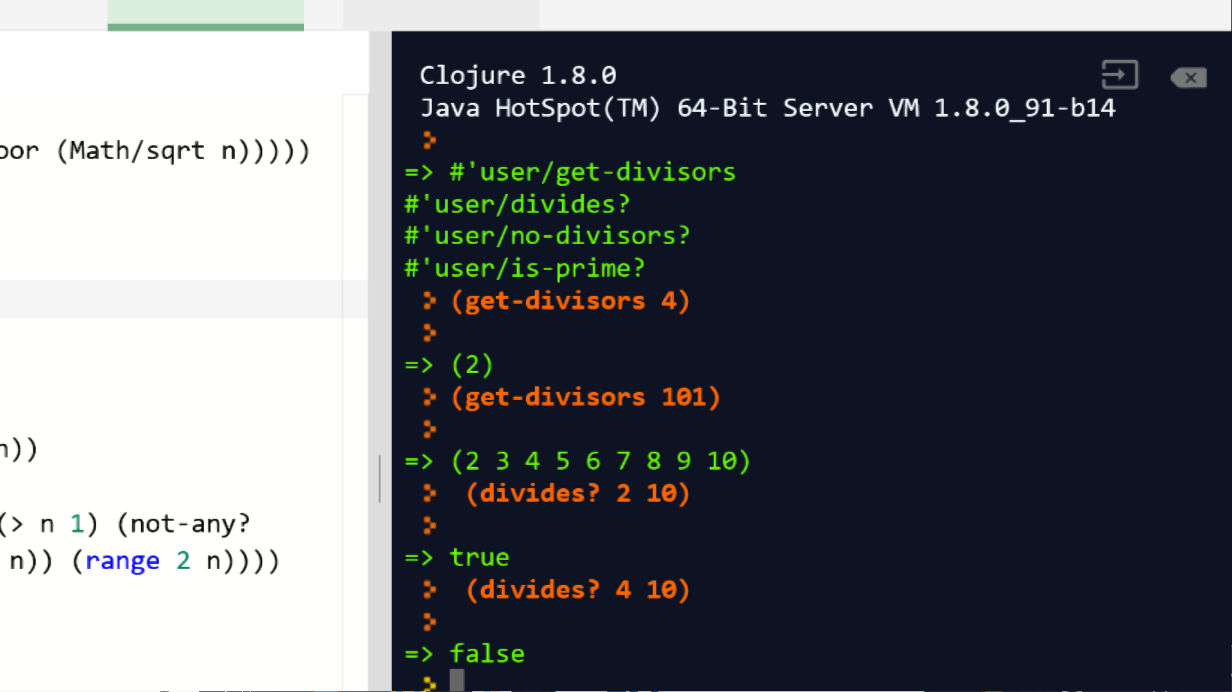

Check (d):

d) Write a function named is-prime? which takes an input n and returns true if n is prime, and false otherwise. This function should check to see if n is 1 or 2 and respond accordingly; if not, it should call your no-divisors? function. For example:

<https://repl.it/@t4_talha/StickyFoolishMonitors>